STEPS OF EXECUTION
- COPY PLANTLD FLODER INTO C:\Users\Dell\AppData\Local\Programs\Python\Python36
- RUN TRAINING FILE , CHANGE THE PATHS
C:\Users\Dell\AppData\Local\Programs\Python\Python36\PLANTLD\Dataset\test
C:\Users\Dell\AppData\Local\Programs\Python\Python36\PLANTLD\Dataset\train
C:\Users\Dell\AppData\Local\Programs\Python\Python36\PLANTLD\Dataset\val
- RUN LEAF.PY
COPY THE HTTP LOCAL SERVER PATH AND CHECK

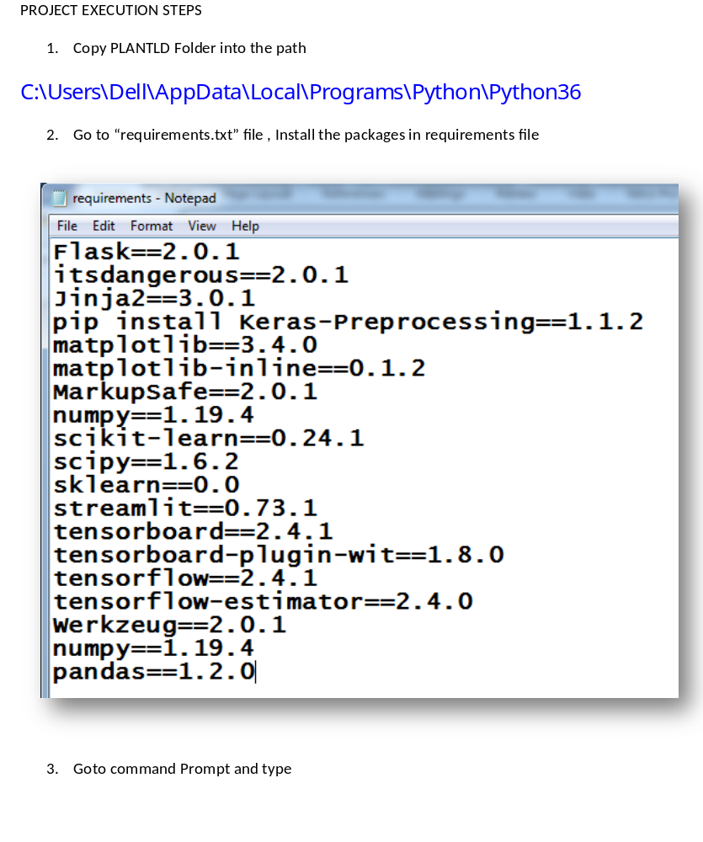pip install -r requirements.txt

